***TEAM MOBILE-EDU-04***

***THINKER MOBILE APPLICATION DESIGN***

**Introduction**

Are you a student currently learning in an educational institution? Or are you someone taking advantage of the new world and learning remotely? Do you sometimes have challenges breaking down certain concepts, taking on that task, or just stuck in breaking down theories in your mind? and you just want to share, exchange ideas, discuss and think with other great students?  ***Thinker*** can help you

* Connect with likeminded smart students in a distraction free environment
* Discuss, share and think alongside other smart students about academic topics
* Share your difficult academic tasks and get feedback on how other students are tackling such tasks
* Build academic relationships across different parts of the world and see best practices other students are adopting to stimulate learning.

Basically, ***thinker*** is an android application that uses your Android device to make you a global student, with an army of thinking minds across the world to help you become a better student.

**Storyboard/Wireframe**

App has 5 major sections/screens

1. Students creates an account

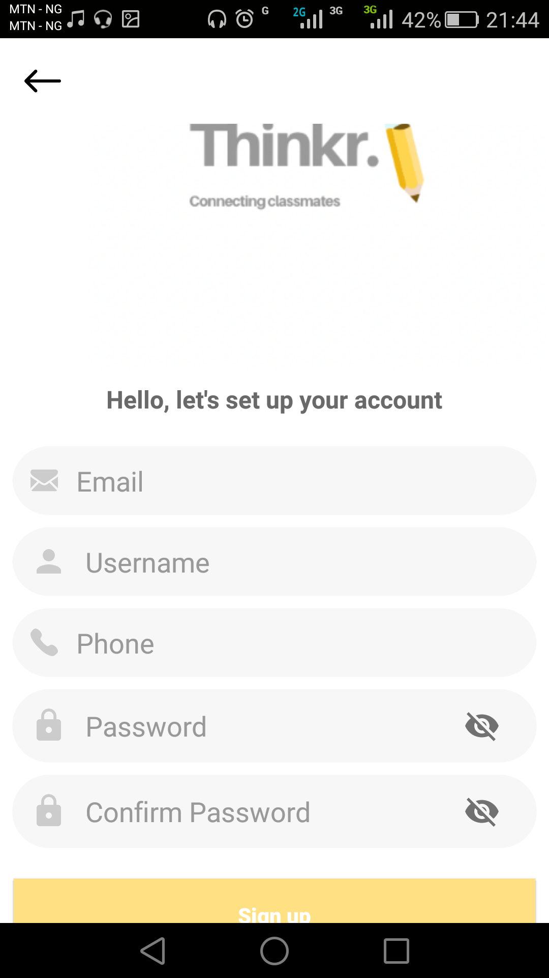

1. Student can log into created account

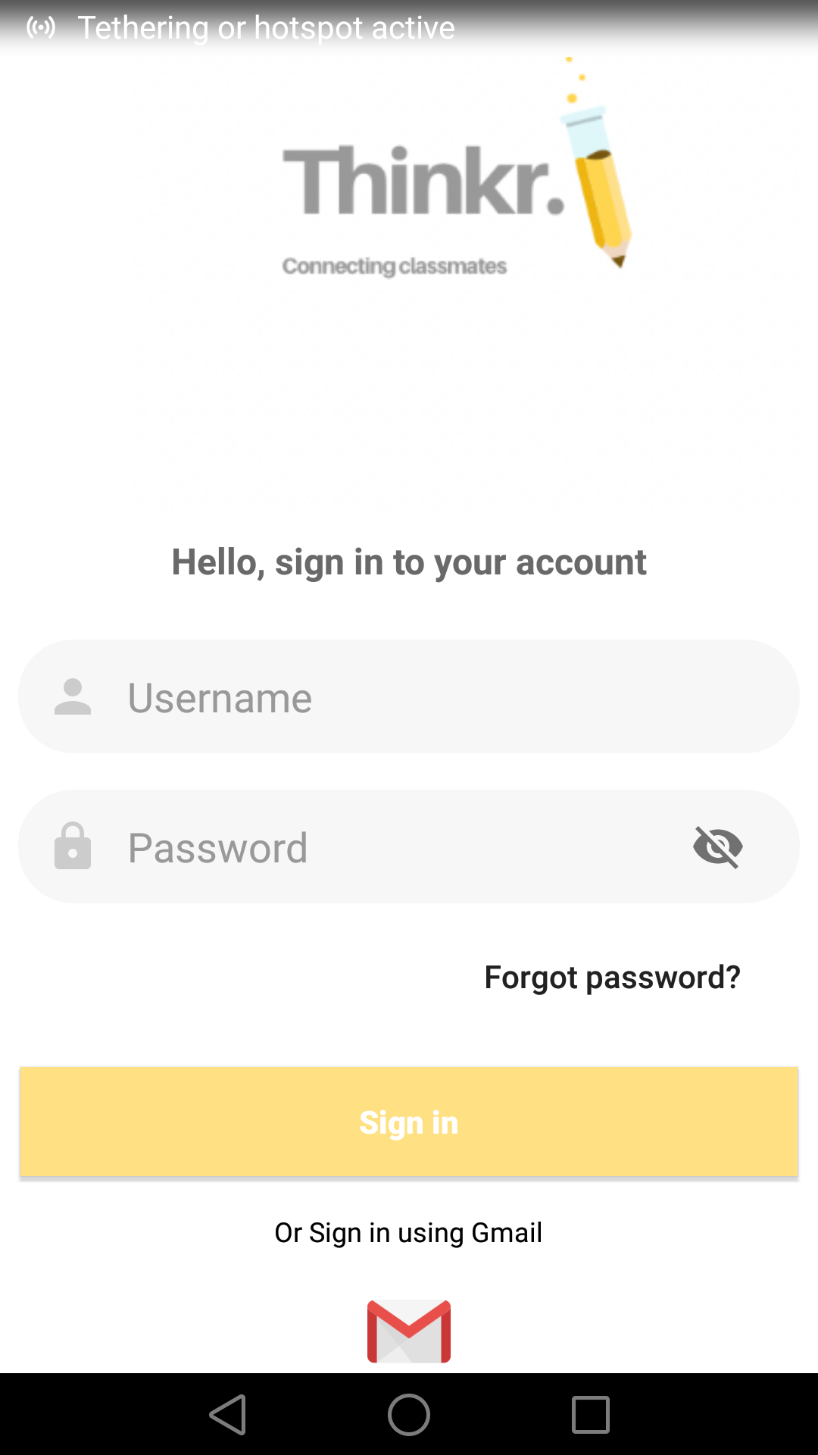

1. Student can join a thinking room based on subjects for discussion

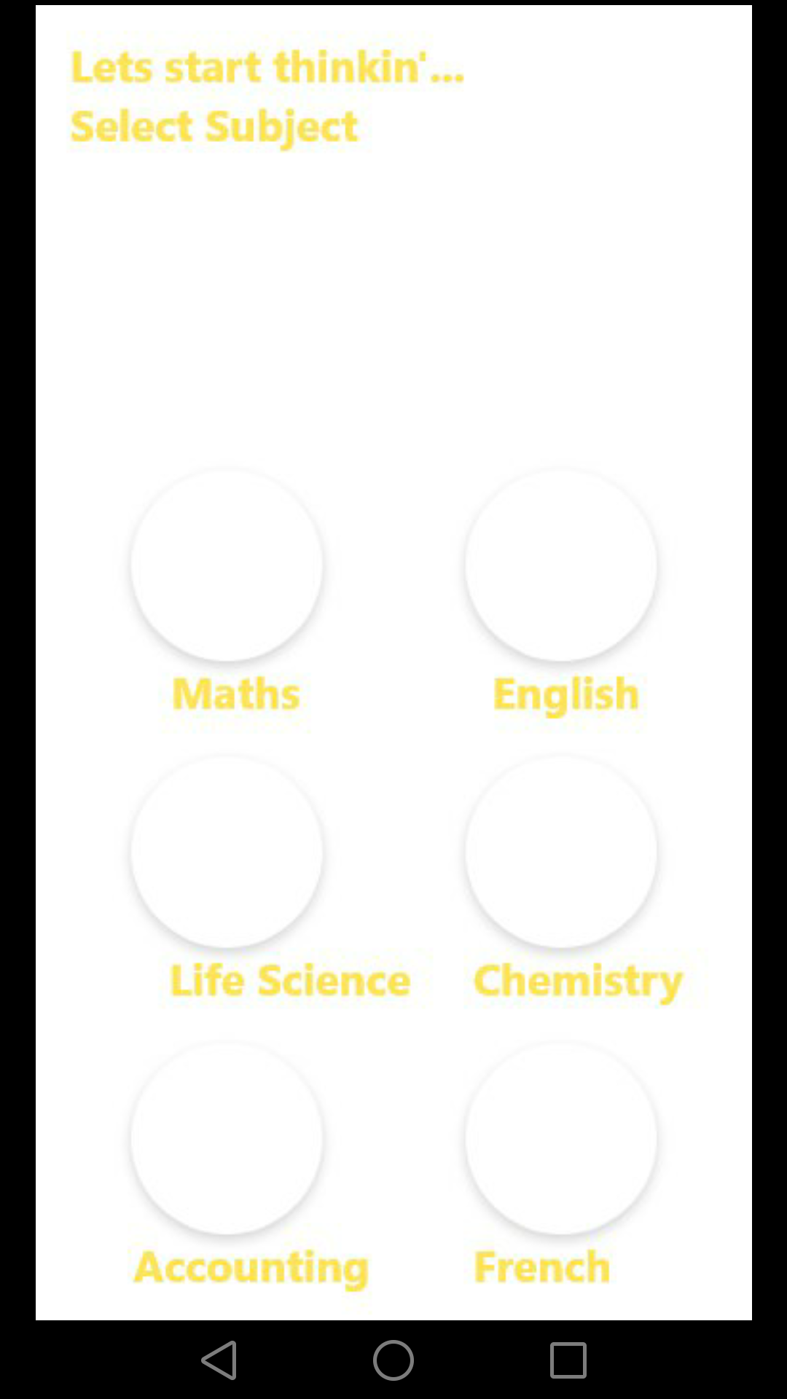

1. User can post a thought (or in our case a “***think***”) which might carry an image attachment

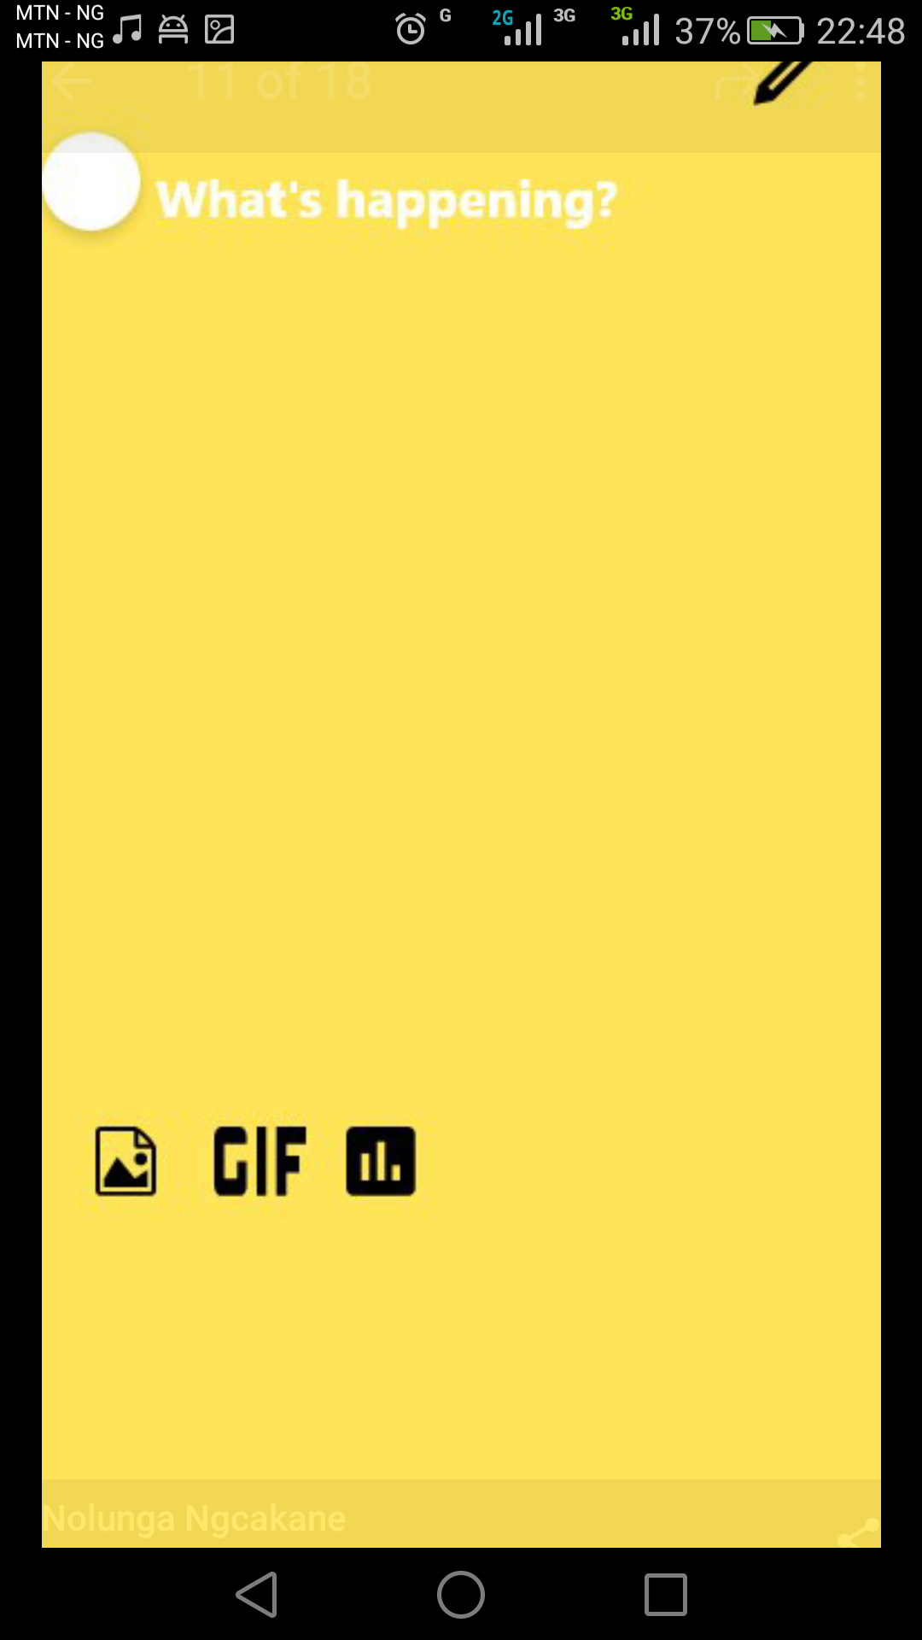

5)User can directly chat up or video call another student to ***think*** and discuss more

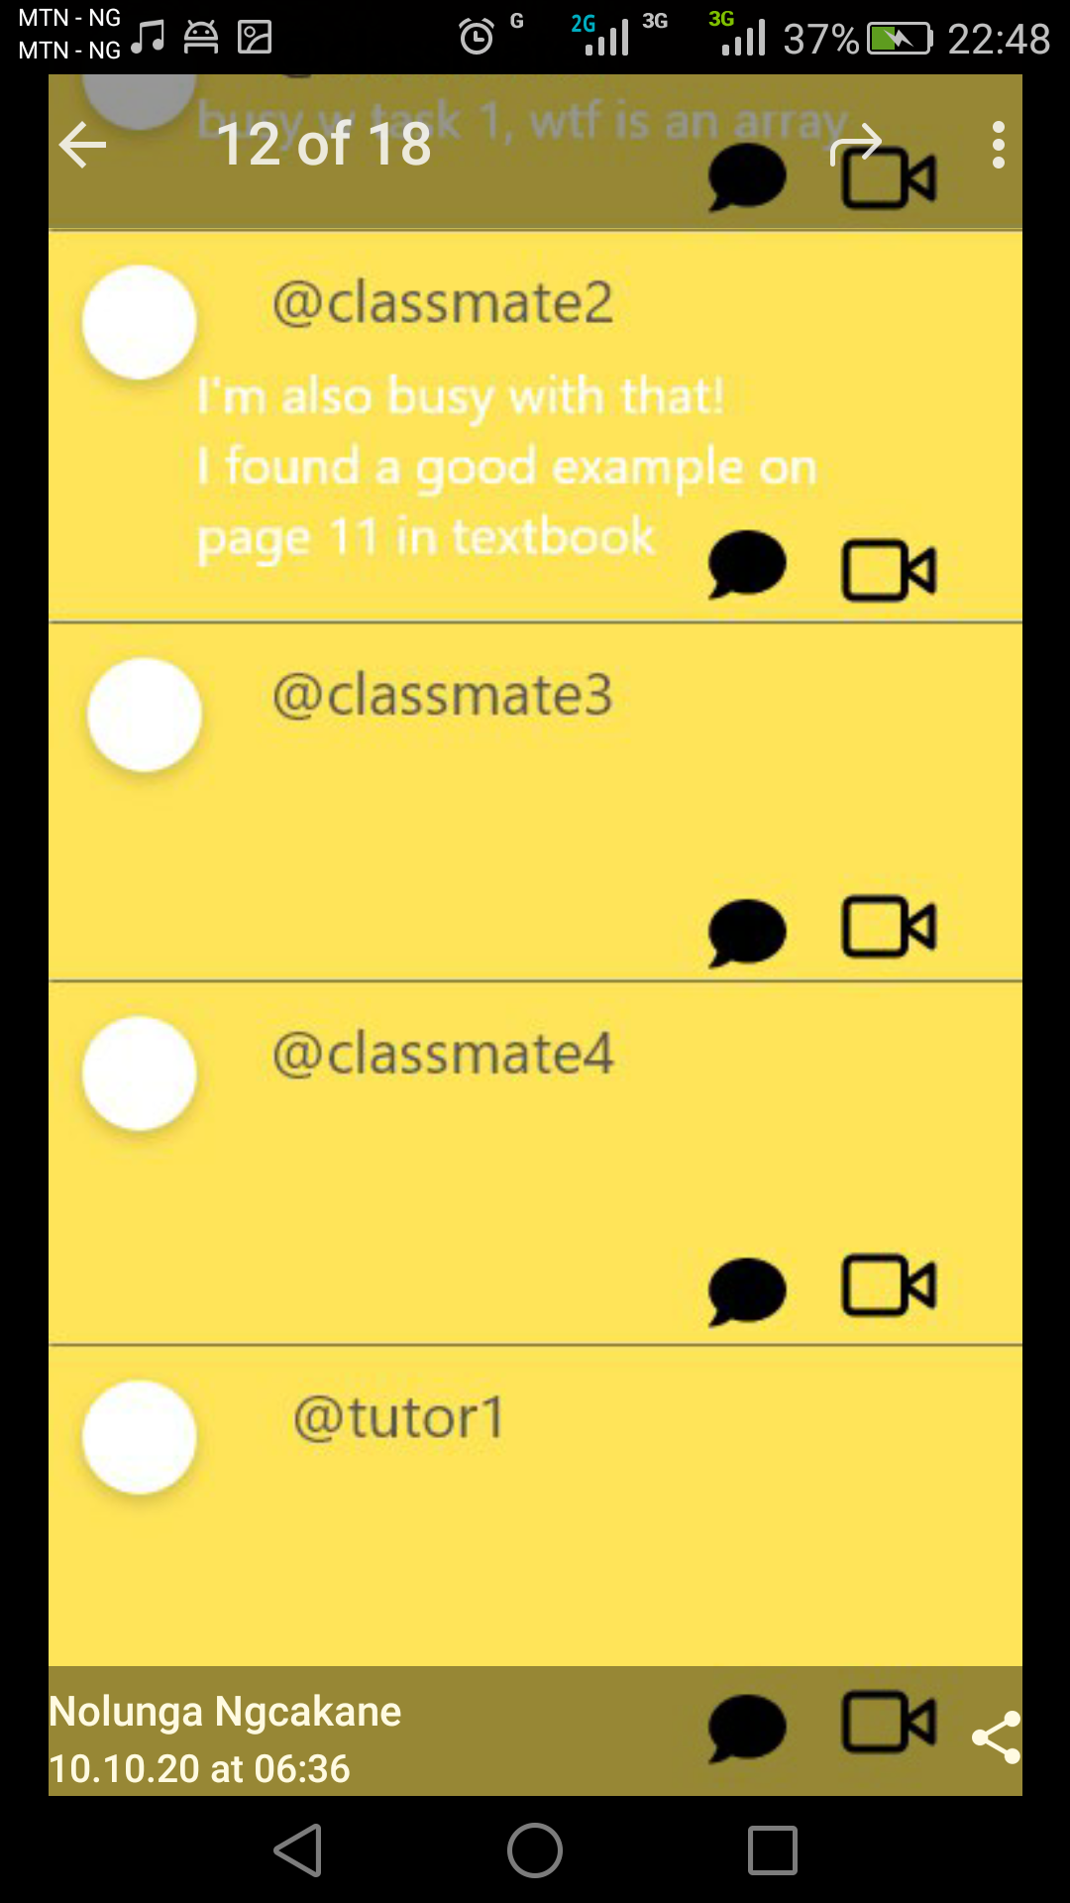

**Functional Requirements**

The app should allow students create new accounts

Sign into their accounts and Sign out freely

Select a thinking room which could be based on school subjects such as Chemistry, Physics, Biology.

Join the room and start thinking alongside other students, in the form of posting messages

Post thoughts (or in our app’s case ***think***)

Post would be in form of text messages and can also carry an attached picture (media file) for better explanation of concepts

Allow student see what has been discussed in the room via notifications

Allow students chat with other students via Video Calling

As this is an academic app, it would have to ensure a distraction free zone, thus the app would be devoid of advertisement and any other form of distractions that could lead students off topic

**Tools and Hardware**

Thinker is an android application thus will require the use of Android Studio IDE for building it.

The app would be built using Google’s Kotlin language in Android Studio

Thinker would allow users to create profiles and chat with other classmates and students thus this data would be stored somewhere and the team would be utilizing Google’s Firebase platform for this purpose.

As thinker is an android application, thus would require creation and testing on android mobile devices with at least minimum API of 21.

**UX Testing**

The app would be continuously tested by members of the building team from Android studio coding tests to physical user feedback test, and also tested by the team assigned PA (Program Assistant) before its final submission and release.

**Visuals, Navigation and Interactivity**

Thinker app has a bright yellow colored theme and white as this brings a feeling of warmth and ease to student’s challenges. the app Navigation is made easy for all, with buttons, icons and easy to spot navigation triggers even first timers to the app would find moving around easy, also the Interactivity is made easy for all to use.

**Target Market**

Thinker is primarily targeted at secondary school students as well as students learning remotely as the ability to quickly share a bugging academic thought with another student provides an easier and more interactive educational life.

**Team and Delivery Timeline**

Thinker is being built by members of the Google Africa Developer Scholarship GADS2020 community project phase members of team Mobile-Edu-04 and the task are assigned to active and participating members from the team lead with a view to wrapping up the project by the end of October 2020, as it is a One month project.

**Installation Guidelines**

Soon as the app’s testing is done and the team releases the app, users can download it from the Google Playstore or our provided links and install straight to their android mobile devices and begin utilizing the app.

**Github**

Currently the app repo is available here <https://github.com/Nolunga/Thinkr>